Assignment 7

- (20 pts.) 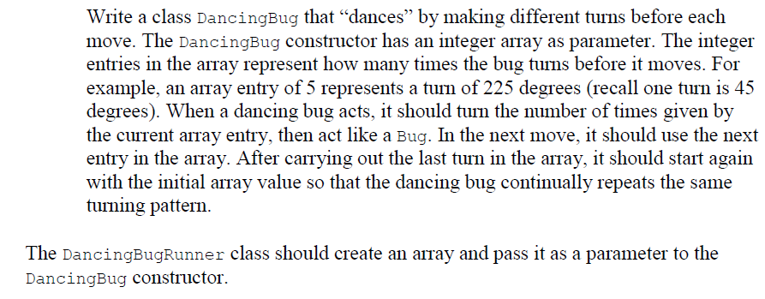
Test the class.

